

**IBM Cloud**

**Analytics, Blockchain and Internet of Things (IoT)**

**Instructor Lab Guide**

Notices and Disclaimers

© Copyright IBM Corporation 2018.

The information contained in these materials is provided for informational purposes only, and is provided AS IS without warranty of any kind, express or implied. IBM shall not be responsible for any damages arising out of the use of, or otherwise related to, these materials. Nothing contained in these materials is intended to, nor shall have the effect of, creating any warranties or representations from IBM or its suppliers or licensors, or altering the terms and conditions of the applicable license agreement governing the use of IBM software. References in these materials to IBM products, programs, or services do not imply that they will be available in all countries in which IBM operates. This information is based on current IBM product plans and strategy, which are subject to change by IBM without notice. Product release dates and/or capabilities referenced in these materials may change at any time at IBM’s sole discretion based on market opportunities or other factors, and are not intended to be a commitment to future product or feature availability in any way.

This document is current as of the initial date of publication and may be changed by IBM at any time. Not all offerings are available in every country in which IBM operates.

IBM, the IBM logo and ibm.com are trademarks or registered trademarks of International Business Machines Corporation in the United States, other countries, or both. If these and other IBM trademarked terms are marked on their first occurrence in this information with a trademark symbol (® or ™), these symbols indicate U.S. registered or common law trademarks owned by IBM at the time this information was published. Such trademarks may also be registered or common law trademarks in other countries. A current list of IBM trademarks is available on the Web at “Copyright and trademark information” at ibm.com/legal/copytrade.shtml

Other company, product and service names may be trademarks or service marks of others

**Document Revision History**

|  |  |  |
| --- | --- | --- |
| Rev # | File Name | Date |
| 1.0 | Blockchain and IoT Instructor Lab Guide | 9/14/2018 |

**Prepared & Revised by:**

Loren Murphy – [lrmurphy@us.ibm.com](mailto:lrmurphy@us.ibm.com)

Dave Wakeman – [dwakeman@us.ibm.com](mailto:dwakeman@us.ibm.com)

**Table of Contents**

Instructor Lab Guide 5

Lab Environment Overview 6

Setup Blockchain Environment 7

Clean Up Blockchain Environment 14

# Instructor Lab Guide

The purpose of this lab guide is to show you how to setup the workshop lab environment for the Blockchain and IoT Lab. The lab is based on the IBM Code Pattern, “[IoT Asset Tracking on a Blockchain](https://developer.ibm.com/code/2018/04/30/iot-asset-tracking-blockchain-immutable-where-what-when/)”

**Lab Overview**

Our global economy and populations depend on safe delivery of perishable goods (food, medicine, livestock, etc.). Whenever public health officials issue a warning about bacterial outbreaks affecting the food supply, there are investigations into the source and cause of the contamination. Often these perishable goods are sensitive to environmental conditions during shipment. Were the perishable goods exposed to extreme temperatures? To preserve freshness, shipments of perishable goods might have refrigeration requirements because no one wants to eat unsafely warmed meat or bruised apples. If the shipment exceeds these temperature thresholds, the goods are likely damaged and might become a health hazard.

Tracking the conditions of the shipment across multiple participants using a blockchain provides verification and trust, while sensors within the shipment records environmental conditions in real-time. Is the truck refrigeration sufficient for this particular type of good? What temperature ranges were prescribed in the Smart Contract? Once it arrives at the final destination, is this shipment still safe or damaged?

This lab will simulate a temperature sensor within a shipment of perishable goods. As the truck travels to its final destination, the temperature, location, and reading time of shipment will be recorded in the blockchain. The shipment information will also be sent to the Watson IoT platform for further real-time analysis and persisted within Db2 on Cloud for further analysis and visualization.

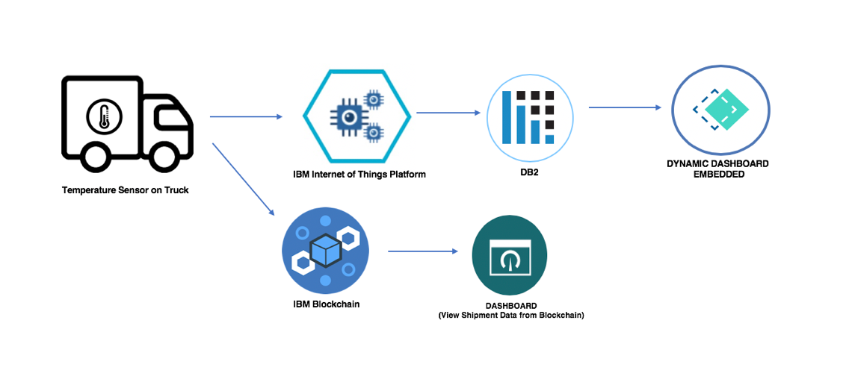

# 

# Lab Environment Overview

**Software and Tools**

|  |  |
| --- | --- |
| **Software** | **Link** |
| **GitHub** | https://github.com/team-wolfpack |
| **IBM Cloud** | https://www.ibm.com/cloud/ |

**Note:** We know Composer is no longer being invested in; however, the lab should still work.

**Troubleshooting Tips:**

* If you received a “no response from server” error, stop then restart your Blockchain API service.

# Setup Blockchain Environment

| Action |
| --- |
| **1.Setup Blockchain Environment**   1. Login to IBM Cloud account <https://console.bluemix.net/catalog/> 2. In the catalog, search **Blockchain** and select the **Blockchain service**  1. Keep the default name or provide a unique name. Select the **Starter Membership Plan** and click **Create**  1. Go to the Starter Toolchain: <https://console.bluemix.net/devops/setup/deploy/?repository=https%3A//github.com/IBM-Blockchain-Starter-Kit/blockchain-toolchain&branch=master&env_id=ibm%3Ayp%3Aus-south&deploy-region=ibm%3Ayp%3Aus-south&sampleRepo=https%3A//github.com/IBM-Blockchain-Starter-Kit/blockchain-sample-bootstrap>      1. Click **Delivery Pipeline**. Change the blockchain service name to the **same name as your blockchain service** which you defined in step C. Rename or keep the default cloudant service name. Change the app name or keep default.  1. Click **Create** to create a Cloud API Key. Click **Create**  1. Select the same **Region**, **Organization** and **Space** for where you provisioned the blockchain service  1. Click **Create**  1. Click on the “GitHub” link within the tool chain. Clone the repo locally to your computer. 2. Unzip the IoT-Perishable-Network,zip file and move the IoT Perishable Network folder into the “Contracts” folder. **Delete the readme.md file in the contracts folder and also delete the readme.md file in the apps folder** 3. Commit your changes and push them to GitHub. This will trigger the build step of the pipeline you just created. 4. Once the build step finishes, the deploy step triggers. Once that finishes, go back to the dashboard. You should see a service was created. This is your composer rest server (API). 5. Click on the service. And “Visit app URL.” If you want to pre-populate data for demos, go to “SetupDemo.” Click on “example value” to copy its contents into the value box. Delete the timestamp, and transactionID. And click “Try it out”. 6. To make sure data was populated go to “Contract” , “get” and try the example value. 7. In the Node-RED flow, make sure you change the **HyperLedgerFabricIP** to your Blockchain URL. This is found within the **Set Device ID** node in the **Init Flow**.  1. **IMPORTANT:** Make sure you give the workshop participants the URL so they can also update their Set Device ID node. |

# Clean Up Blockchain Environment

| Action |
| --- |
| **1.Clean Up Blockchain Environment**   1. After the workshop, make sure you delete the participant’s shipment IDs in the blockchain by following the steps below: 2. Go to your IBM Cloud dashboard and click on your **Blockchain Application**  1. Select **Visit App URL** to open your Blockchain API Platform.  1. Select **Shipment** then **Get/Shipment**  1. Click **Try it Out** to return a list of all the shipment IDs in the blockchain. Copy one of the Shipment IDs.  1. Click **Delete /Shipment/{id}** and paste the Shipment ID you just copied into the **Value** box. Click **Try it Out**.  1. You should receive a **Response Body** of “**no content**” and a **Response Code** of “**204**”. You have now successfully deleted that Shipment ID within your blockchain. **Repeat steps D- F** for the remaining shipment IDs that were created within your workshop. |